Converting Netezza DDL to SQL Data Warehouse

# Overview

This blog is intended to provide guidance for converting a Netezza platform to Azure Data Warehouse(SQLDW). This also provides a PowerShell script that will convert an extracted Netezza DDL to SQLDW.

# Problem

Migrating Netezza to SQLDW requires several steps.

1. Data needs to be extracted from Netezza
2. The Netezza DDL needs to be converted to SQLDW format.
3. The data needs to be loaded into SQLDW.

This article will assume step 1 (Data Extraction) has been completed, the data is in UTF8 format, uploaded to Azure Blob Storage and ready to load into SQLDW.

This article will concentrate on how to convert the DDL and load the data into SQLDW.

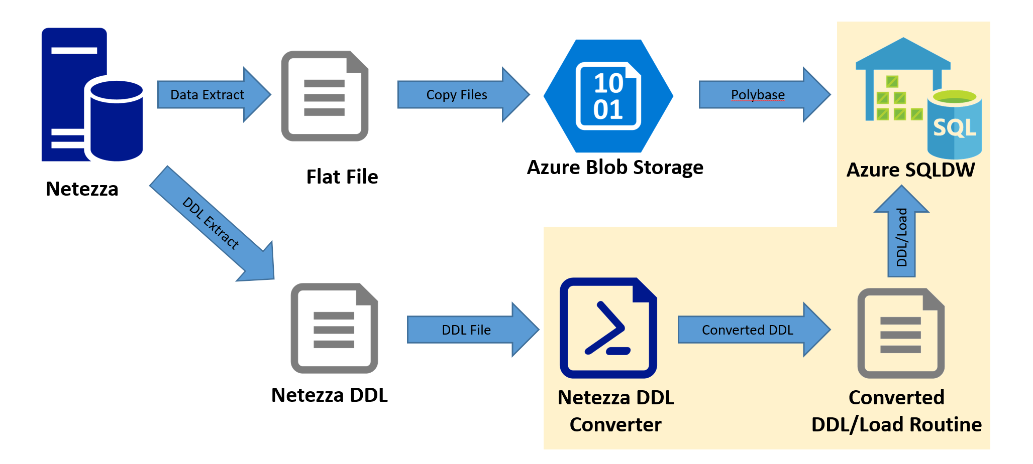

# Solution

The diagram above shows the flow of data and DDL from Netezza to SQLDW. The DDL is first extracted from Netezza and then read into the DDL converter. Currently, the tool only converts Tables and does not support all Netezza objects.

The DDL converter completes the following tasks:

1. Creates the External tables necessary to load the extracted Data into SQLDW. Appendix A: Netezza DDL Sample
2. Loads the data from the external table into the destination table
3. Creates a Clustered Column Store Index on the on the Destination Table.

Prerequisites:

1. Netezza DDL is extracted using the Netezza Tools. DDL is extracted into a single file. This should just be the Create Tables. Views, Stored Procedures and other Netezza objects are considered out of scope for hit tool at this time.
2. SQLDW is configured for Polybase
3. Data Source for Polybase has been created
4. File Format for Polybase has been created
5. Create the Log table on SQLDW for tracking the Load Process. See Appendix B.

To get stared Open the ConvertNetezza_to_SQLDW.ps1 File in a Powershell Editor.

In the Script there are several line that need to be edited for your environment.

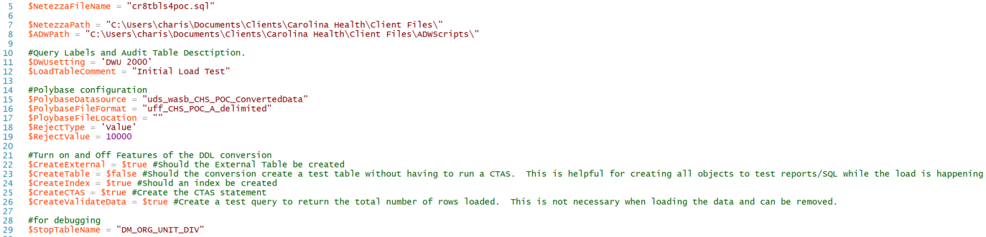

Edit the Following lines:

* Line 5: Enter the name of the Extracted Netezza DDL.
* Line 7: Location where the Extracted Netezza DDL is stored.
* Line 8: Location where the converted .SQL file will be stored.
* Line 11: This is the text that is entered into the log table when running the converted DDL and loading the data to indicate the DWU the SQLDW was running.
* Line 12: This is the text for the LoadComment Column in the Load_Times Table.
* Line 15: Name of the Polybase Data Source created in SQLDW.
* Line 16: Name of the Polybase File Format created in SQLDW.
* Line 17: Location in WASB where the FlatFiles are stored. This is the Directory structure. It is assumed that each table will have its own location based on the table name.
* Line 18: RejectType to use when loading the data using Polybase.
* Line 19: RejectValue to use when loading the data using Polybase.

This section controls what is generated by the DDL migration process.

* Line 22: Should the External Table be created?
* Line 23: Should the conversion create a test table without having to run a CTAS. This is helpful for creating all objects to test reports/SQL while the load is happening.
* Line 24: Should an index be created
* Line 25: Create the CTAS statement
* Line 26: Create a test query to return the total number of rows loaded. This is not necessary when loading the data and can be removed.

# What Gets Converted

Currently the converter can only convert table structures and has limited functionality to perform the following:

**Data Types conversions:**

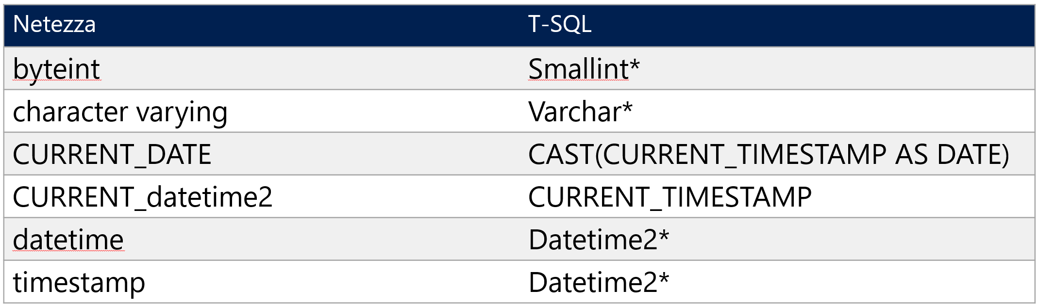

**Current limitations:**

Default values are removed from all columns as external tables do not support defaults.

# Output from Converter

After running the converter, each table in the Netezza DDL will generate a separate script for creating the External Table and loading the data into the final table. Each of these scripts can then be run individually through SSMS or through the Load Automation PowerShell script.

The Following DDL would be converted into the following script:

**Netezza Script**

CREATE TABLE CD_DMN

(

DMN_SK integer not null,

DMN_NM character varying(30) not null,

DMN_DESC character varying(250) not null,

DMN_COL_NM character varying(1024),

LOAD_INFO_SK bigint not null,

MAP_REQD_IND numeric(1,0) not null,

TENANT_CMN_CD_OVRD_IND numeric(1,0),

SRC_ACT_IND integer not null default 1,

SRC_CRE_TS timestamp,

SRC_UPDT_TS timestamp

,Constraint CD_DMN_UK UNIQUE (DMN_NM)

)

DISTRIBUTE ON (DMN_SK)

;

\echo

\echo ***** Adding Primary Key Constraint: CD_DMN

ALTER TABLE CD_DMN ADD PRIMARY KEY (DMN_SK);

**Converter Output:**

A file is generated for each table in the DDL. This File is name after the Table: CD_DMN.sql

--- CREATE EXTERNAL DW TABLE ---

if Exists(select 1 from sys.tables where name = 'Ext_CD_DMN') Drop External Table [dbo].[Ext_CD_DMN]

CREATE EXTERNAL TABLE Ext_CD_DMN

(

DMN_SK integer not null,

DMN_NM varchar(30) not null,

DMN_DESC varchar(250) not null,

DMN_COL_NM varchar(1024),

LOAD_INFO_SK bigint not null,

MAP_REQD_IND numeric(1,0) not null,

TENANT_CMN_CD_OVRD_IND numeric(1,0),

SRC_ACT_IND integer not null ,

SRC_CRE_TS datetime2,

SRC_UPDT_TS datetime2

)

WITH (DATA_SOURCE = uds_wasb_CHS_POC_ConvertedData,

LOCATION = N'CD_DMN',

FILE_FORMAT = uff_CHS_POC_A_delimited,

REJECT_TYPE = Value,

REJECT_VALUE = 10000

)

--- VERIFY EXTERNAL DATA ---

SELECT TOP 10 * FROM [dbo].[EXT_CD_DMN];

--- LOAD DATA VIA CTAS ---

if Exists(select 1 from sys.tables where name = 'CD_DMN') Drop Table [dbo].[CD_DMN]

Declare @start datetime

Set @start = getdate()

Create table CD_DMN With (Distribution = Hash(DMN_SK), Heap) As

Select * from [dbo].[Ext_CD_DMN] option (label = 'Data Load for Table: CD_DMN At: DWU 2000')

Insert into Load_Times(Tablename, Duration, DWU, Load_Comment, CreateDate) Select 'CD_DMN', DateDiff(ss, @start, getdate()), 'DWU 2000', 'Initial Load Test', getdate()

--- CREATE THE INDEX ---

Create Clustered ColumnStore Index IdxCCI_CD_DMN on CD_DMN

--- VALIDATE THE LOADED DATA ---

select count(*) as Row_Count, 'CD_DMN' as TableName from [dbo].[CD_DMN]

# Appendix A – Netezza DDL Sample

\echo

\echo ***** Creating table: "CAL_DM"

CREATE TABLE CAL_DM

(

CAL_DK bigint not null,

CAL_DT timestamp,

CAL_DT_FULL_NM character varying(30) not null,

CAL_DT_ABBREV character varying(150) not null,

YR_NBR integer not null,

MTH_OF_YR_NBR smallint not null,

MTH_OF_YR_ABBREV character(3) not null,

MTH_OF_YR_NM character varying(30) not null,

MTH_AND_YR_NBR integer not null,

MTH_AND_YR_ABBREV character varying(20) not null,

MTH_AND_YR_NM character varying(30) not null,

QTR_OF_YR_NBR smallint not null,

QTR_OF_YR_ABBREV character(2) not null,

QTR_AND_YR_NBR integer not null,

QTR_AND_YR_ABBREV character varying(20) not null,

DY_OF_YR_NBR smallint not null,

DY_OF_MTH_NBR smallint not null,

DY_OF_WK_NBR smallint not null,

DY_OF_WK_ABBREV character(3) not null,

DY_OF_WK_NM character varying(30) not null,

WK_OF_YR_NBR smallint not null,

PRV_YR_NBR integer not null,

PRV_MTH_OF_YR_NBR smallint not null,

PRV_MTH_OF_YR_ABBREV character(3) not null,

PRV_MTH_OF_YR_NM character varying(30) not null,

PRV_MTH_AND_YR_NBR integer not null,

PRV_MTH_AND_YR_ABBREV character varying(20) not null,

PRV_MTH_AND_YR_NM character varying(30) not null,

PRV_QTR_OF_YR_NBR smallint not null,

PRV_QTR_OF_YR_ABBREV character(2) not null,

PRV_QTR_AND_YR_NBR integer not null,

PRV_QTR_AND_YR_ABBREV character varying(20) not null,

FY_NBR integer,

FY_BEGIN_DT timestamp,

FY_END_DT timestamp,

FISC_QTR_NBR smallint,

FISC_QTR_ABBREV character(2),

FISC_QTR_BEGIN_DT timestamp,

FISC_QTR_END_DT timestamp,

FISC_MTH_NBR smallint,

FISC_MTH_ABBREV character(3),

FISC_MTH_NM character varying(30),

FISC_MTH_BEGIN_DT timestamp,

FISC_MTH_END_DT timestamp,

PRV_FY_NBR integer,

PRV_FY_BEGIN_DT timestamp,

PRV_FY_END_DT timestamp,

PRV_FISC_QTR_NBR smallint,

PRV_FISC_QTR_ABBREV character(2),

PRV_FISC_QTR_BEGIN_DT timestamp,

PRV_FISC_QTR_END_DT timestamp,

PRV_FISC_MTH_NBR smallint,

PRV_FISC_MTH_ABBREV character(3),

PRV_FISC_MTH_NM character varying(30),

PRV_FISC_MTH_BEGIN_DT timestamp,

PRV_FISC_MTH_END_DT timestamp,

BUS_DY_IND numeric(1,0) not null,

HOL_IND numeric(1,0) not null,

DT_ERR_IND numeric(1,0) not null,

DT_ERR_DESC character varying(150),

ADJ_PD_IND numeric(1,0),

CHS_ALL_YR_CURR_MTH_IND numeric(1,0) not null,

CHS_ALL_YR_CURR_QTR_IND numeric(1,0) not null,

CHS_ALL_YR_YTD_IND numeric(1,0) not null,

CHS_CURR_YR_CURR_MTH_IND numeric(1,0) not null,

CHS_CURR_YR_CURR_QTR_IND numeric(1,0) not null,

CHS_CURR_YR_YTD_IND numeric(1,0) not null,

CHS_CURR_YR_IND numeric(1,0) not null,

CHS_FIRST_DY_MTH_DT_NBR integer not null,

CHS_FY_NM character varying(30) not null,

CHS_IDX_BILL_LOAD_OFFSET_MTH_NBR integer,

CHS_IDX_BILL_LOAD_OFFSET_YR_NBR integer,

CHS_LAST_DY_MTH_IND numeric(1,0) not null,

CHS_LAST_YR_CURR_MTH_IND integer not null,

CHS_LAST_YR_CURR_QTR_IND integer not null,

CHS_LAST_YR_YTD_IND integer not null,

CHS_LAST_YR_IND integer not null,

CHS_LAST_DY_MTH_NBR integer not null,

CHS_OFFSET_DY_NBR integer,

CHS_OFFSET_MTH_NBR integer,

CHS_OFFSET_QTR_NBR integer,

CHS_OFFSET_WK_NBR integer,

CHS_OFFSET_YR_NBR integer,

CHS_OVRALL_DY_NBR integer not null,

CHS_OVRALL_MTH_NBR integer not null,

CHS_OVRALL_QTR_NBR integer not null,

CHS_OVRALL_WK_NBR integer not null,

CHS_OVRALL_YR_NBR integer not null,

CHS_WK_BEGIN_DT timestamp,

CHS_WK_NBR_BY_DY_NBR integer not null,

CHS_WKDY_WKEND_DESC character varying(30) not null,

DWM_LOAD_INFO_SK bigint not null

)

DISTRIBUTE ON (CAL_DK)

;

\echo

\echo ***** Adding Primary Key Constraint: CAL_DM

ALTER TABLE CAL_DM ADD PRIMARY KEY (CAL_DK);

/*

Number of columns 92

(Variable) Data Size 363 - 1043

Row Overhead 41

====================== =============

Total Row Size (bytes) 404 - 1084

*/

\echo

\echo ***** Creating table: "CD_DMN"

CREATE TABLE CD_DMN

(

DMN_SK integer not null,

DMN_NM character varying(30) not null,

DMN_DESC character varying(250) not null,

DMN_COL_NM character varying(1024),

LOAD_INFO_SK bigint not null,

MAP_REQD_IND numeric(1,0) not null,

TENANT_CMN_CD_OVRD_IND numeric(1,0),

SRC_ACT_IND integer not null default 1,

SRC_CRE_TS timestamp,

SRC_UPDT_TS timestamp

,Constraint CD_DMN_UK UNIQUE (DMN_NM)

)

DISTRIBUTE ON (DMN_SK)

;

\echo

\echo ***** Adding Primary Key Constraint: CD_DMN

ALTER TABLE CD_DMN ADD PRIMARY KEY (DMN_SK);

/*

Number of columns 10

(Variable) Data Size 46 - 1350

Row Overhead 30

====================== =============

Total Row Size (bytes) 76 - 1380

*/

# Appendix B – Load_Times Table

CREATE TABLE [dbo].[Load_Times] (

[TableName] varchar(255) COLLATE SQL_Latin1_General_CP1_CI_AS NULL,

[Duration] bigint NULL,

[DWU] varchar(25) COLLATE SQL_Latin1_General_CP1_CI_AS NULL,

[LoadComment] varchar(200) COLLATE SQL_Latin1_General_CP1_CI_AS NULL,

[CreateDate] datetime

)

WITH (HEAP, DISTRIBUTION = ROUND_ROBIN);

/***This Artifact belongs to the Data SQL Ninja Engineering Team***/